Inventory Management System

Tech stack.HTML,CSS,BOOTSTRAP,JS,PHP,CLOUDINARY,DB()
1. Purpose and Scope
This document defines the functional structure and end-to-end workflow for a multi-location inventory management system. The system covers own manufacturing, externally purchased products, two production units, two warehouses, two shops, website/WhatsApp allocation, shop billing, returns, exchanges, delivery, staff permissions and management reporting.
- Product domains: mother/maternity, baby, girls, kids, toys and essential products.
- Stock sources: own production and products purchased from external sellers.
- Physical locations: Production Unit 1, Production Unit 2, Warehouse 1, Warehouse 2, Shop 1 and Shop 2.
- Sales channels: shops, website and WhatsApp.
- Core principle: every stock change must be traceable to a business transaction.
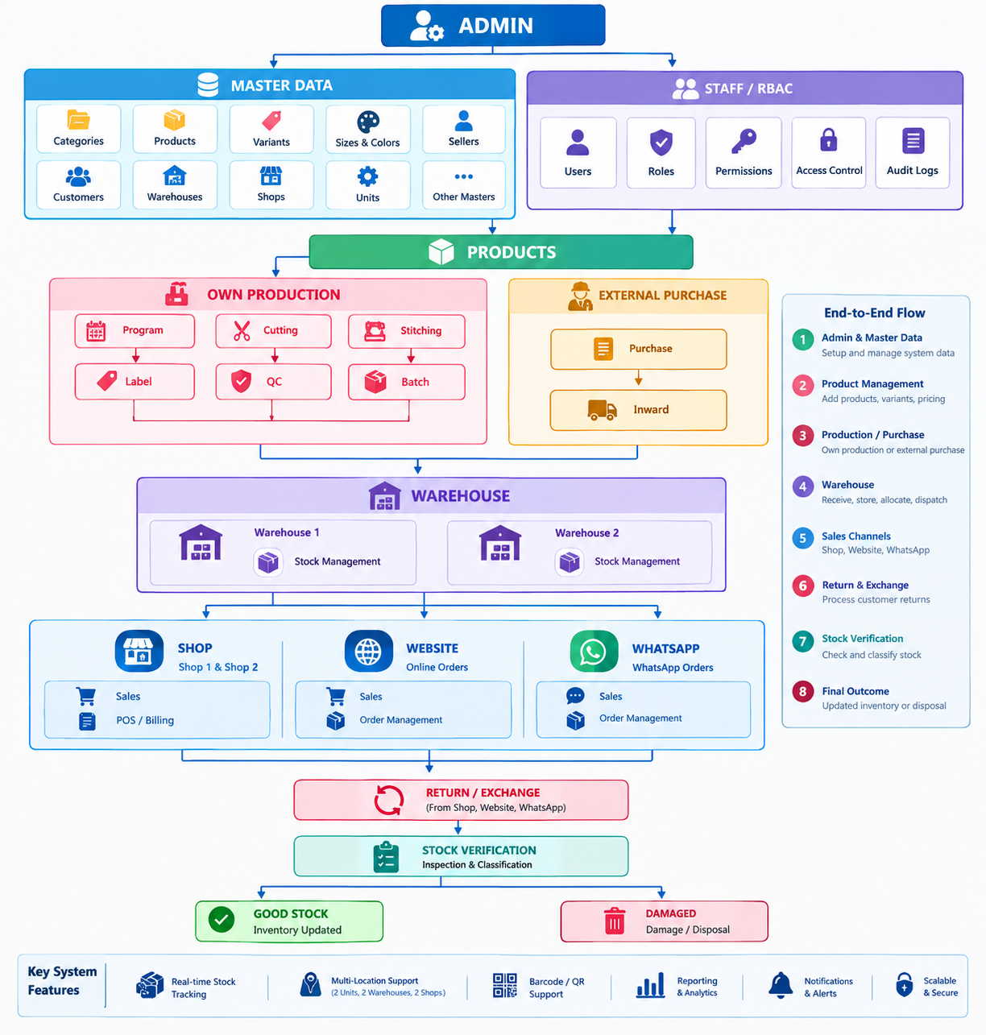

2. Business Structure
Area | Locations / Sources | Primary Responsibility
Production | Production Unit 1 & 2 | Convert production plans into QC-approved finished goods.
Warehouse | Warehouse 1 & 2 | Receive, store, allocate, transfer and dispatch inventory.
Shop | Shop 1 & 2 | Sell products, maintain shop stock and process returns/exchanges.
External Supply | Other sellers | Purchase products and introduce them into warehouse stock.
Digital Sales | Website & WhatsApp | Generate orders fulfilled from allocated/available stock.
Administration | Central management | Master data, approvals, access control and analytics.

3. Overall System Workflow
Master data is created first. Products can then enter inventory through either the internal production route or the external purchase route. Warehouse stock is allocated to sales channels, shops sell through POS(Point of Sale) billing, and all returns/exchanges flow back through controlled inspection and stock transactions.
MASTER DATA → PRODUCTION / PURCHASE → WAREHOUSE → ALLOCATION → SHOP / WEBSITE / WHATSAPP → SALES → RETURN / EXCHANGE → STOCK UPDATE → REPORTS

4. Module Architecture
Module | Submodules
Admin | Dashboard; Production; Warehouse; Shop; Reports; Staff Access
Production | Dashboard; Seller; Catalog; Program; Cutting; Stitching; Label; QC; Outward/Batch; Reports & Analytics
Warehouse | Dashboard; Inward; Stock; Allocation; Other Sellers; Return; Label; Delivery; Transfers; Reports
Shop | Dashboard; Billing/POS; Shop Inventory; Return; Exchange; Sales & Return Reports
Master Data | Categories; Products; Variants; Sizes; Colors; Sellers; Customers; Production Units; Warehouses; Shops; Tax/Pricing
System | Authentication; Roles & Permissions; Notifications; Audit Logs; Settings; Backup
5. Admin Section
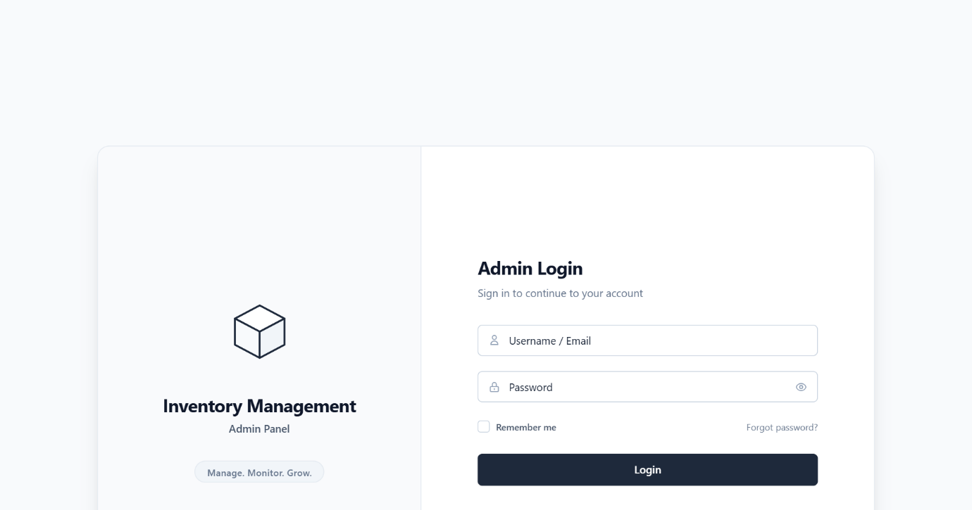

5.1 Dashboard
- Total products and stock value
- Production and QC pending quantities
- Warehouse and shop stock
- Today's/monthly sales and returns
- Pending allocations and deliveries
- Low-stock and out-of-stock alerts
Category, shop and channel performance
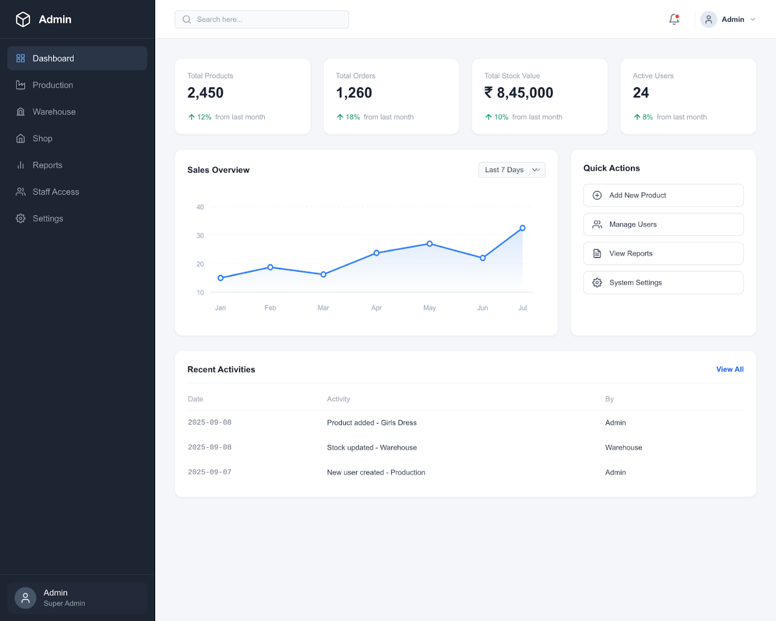

5.2 Production Administration
Provides centralized visibility into programs, cutting, stitching, labeling, QC and completed batches across both production units.
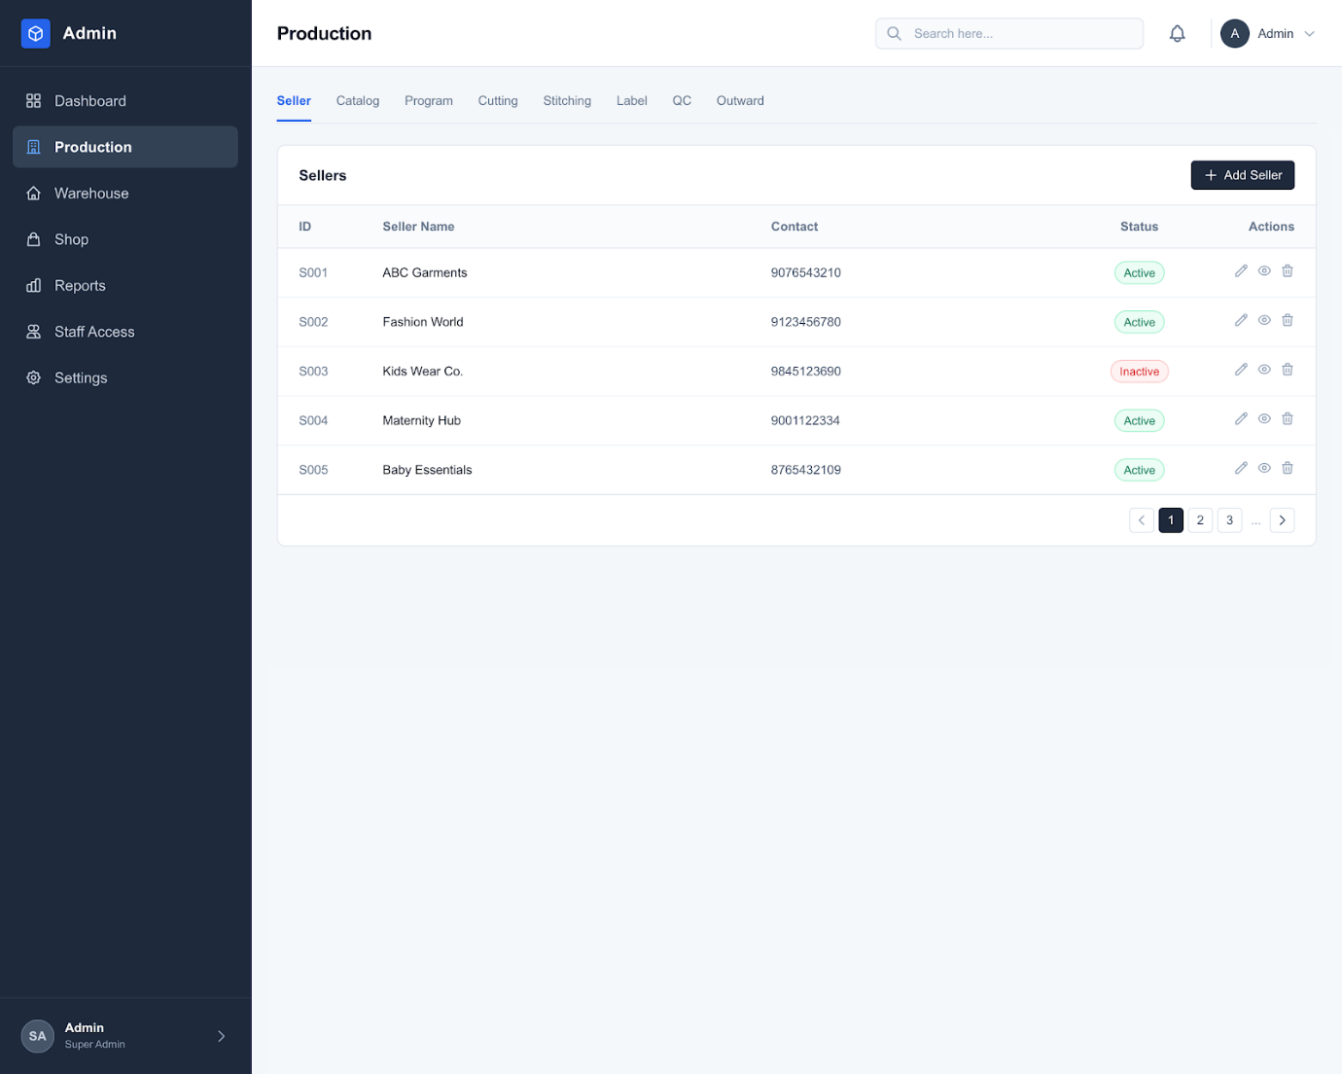

5.3 Warehouse Administration
Provides location-wise stock visibility, inward/outward movement, allocation, transfers, seller purchases, returns and deliveries for both warehouses.
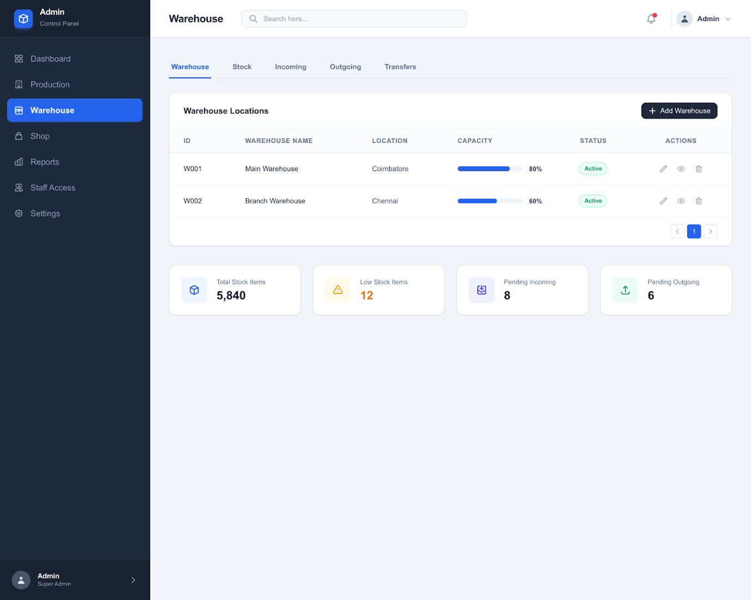

5.4 Shop Administration
Provides shop-wise sales, inventory, billing, returns, exchanges and staff performance.
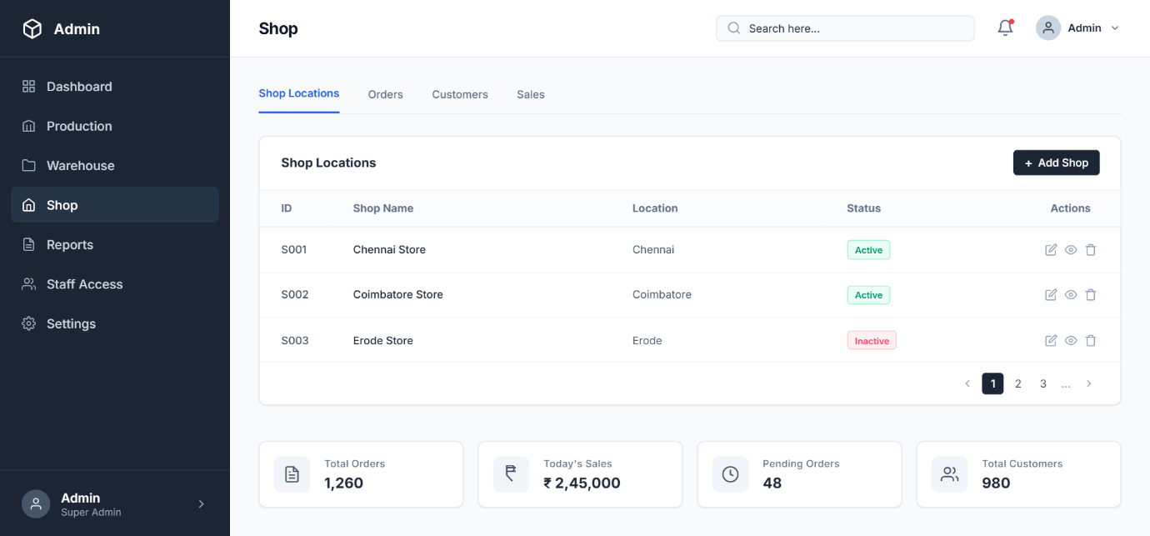

5.5 Reports
Central reporting combines sales, purchases, production, stock, warehouse movements, returns and profitability information.
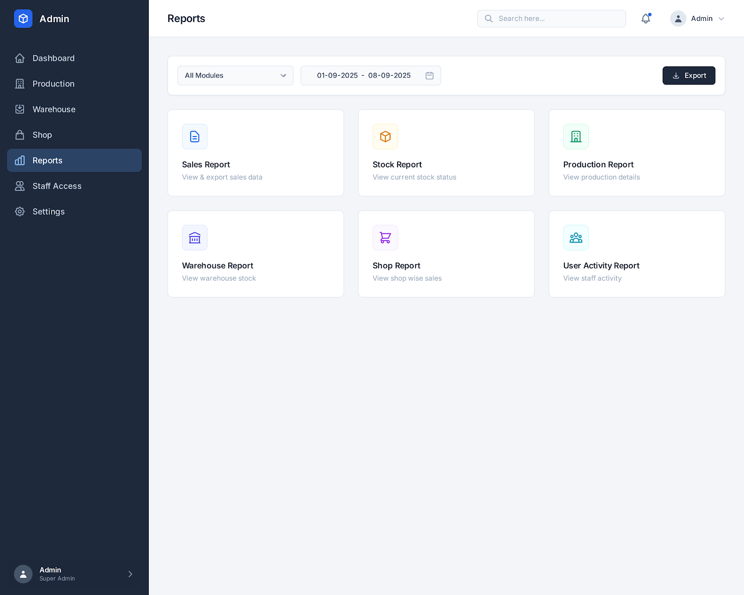

5.6 Staff Access
Users are assigned roles and granular permissions such as view, create, edit, delete, approve, print and export.
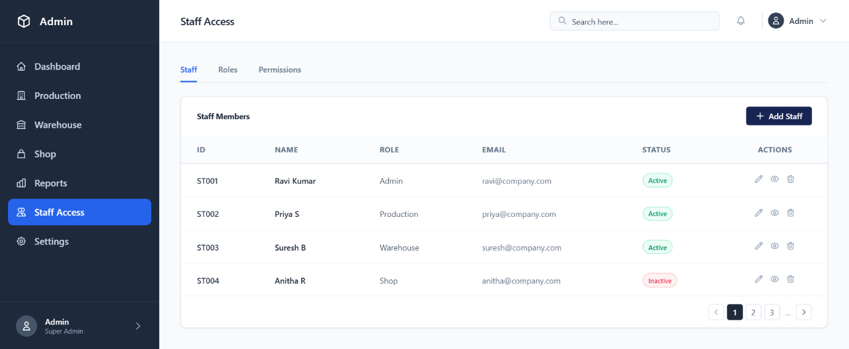

6. Master Data

6.1 Product Master
- Category and subcategory,sub sub category
- Product name/code
- SKU and barcode
- Size and color variants
- Brand and source type
- Material/fabric or product attributes
- MRP, purchase price, production cost and selling price
- GST/HSN
- Minimum and maximum stock
Product image and status
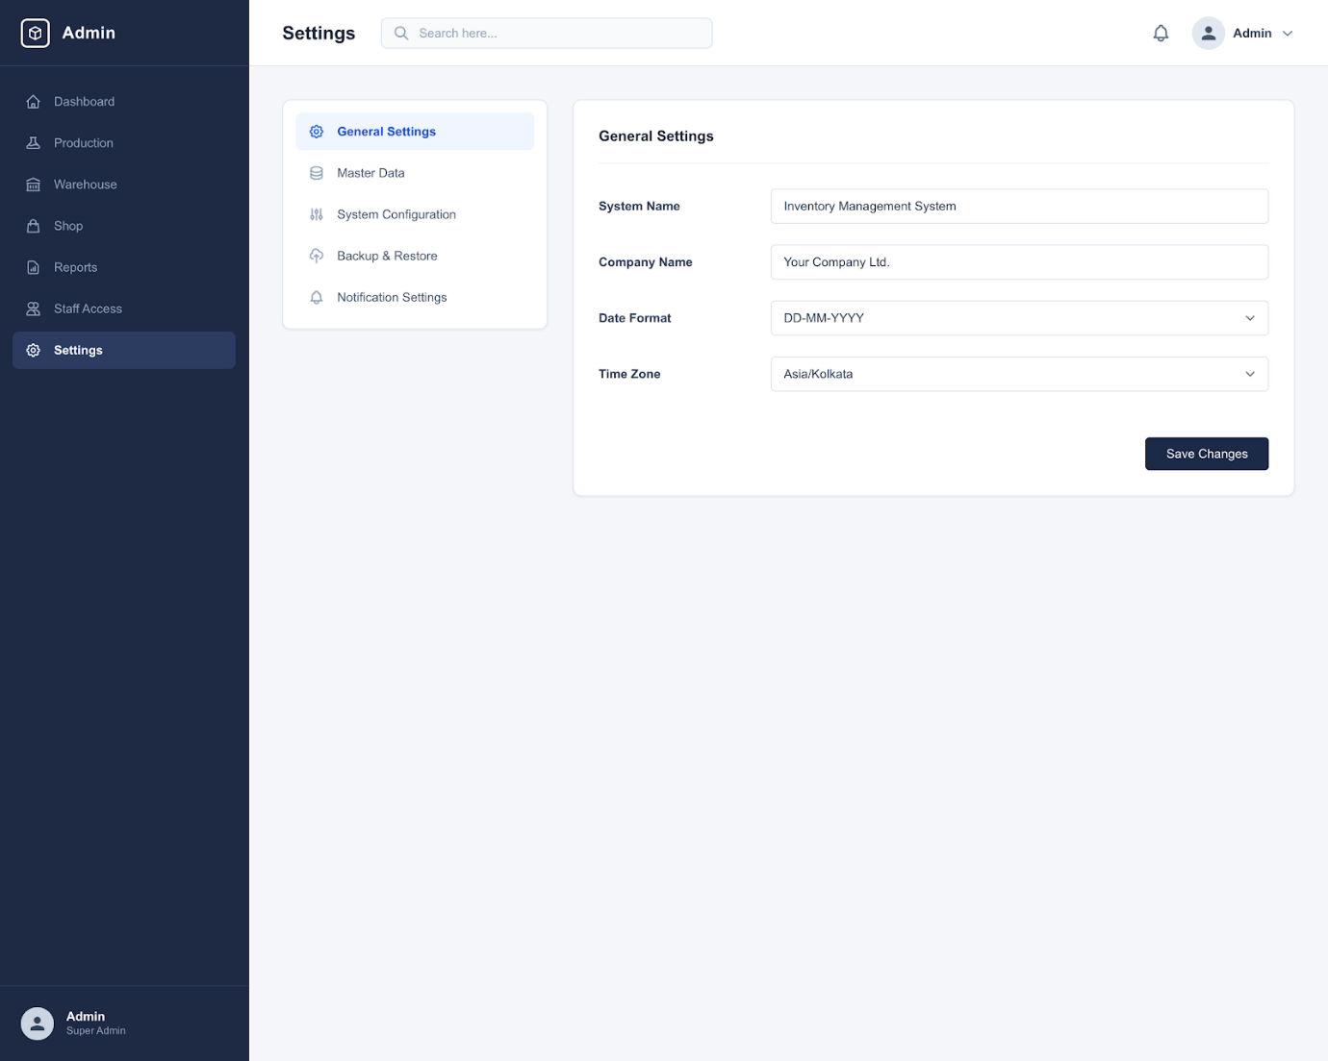
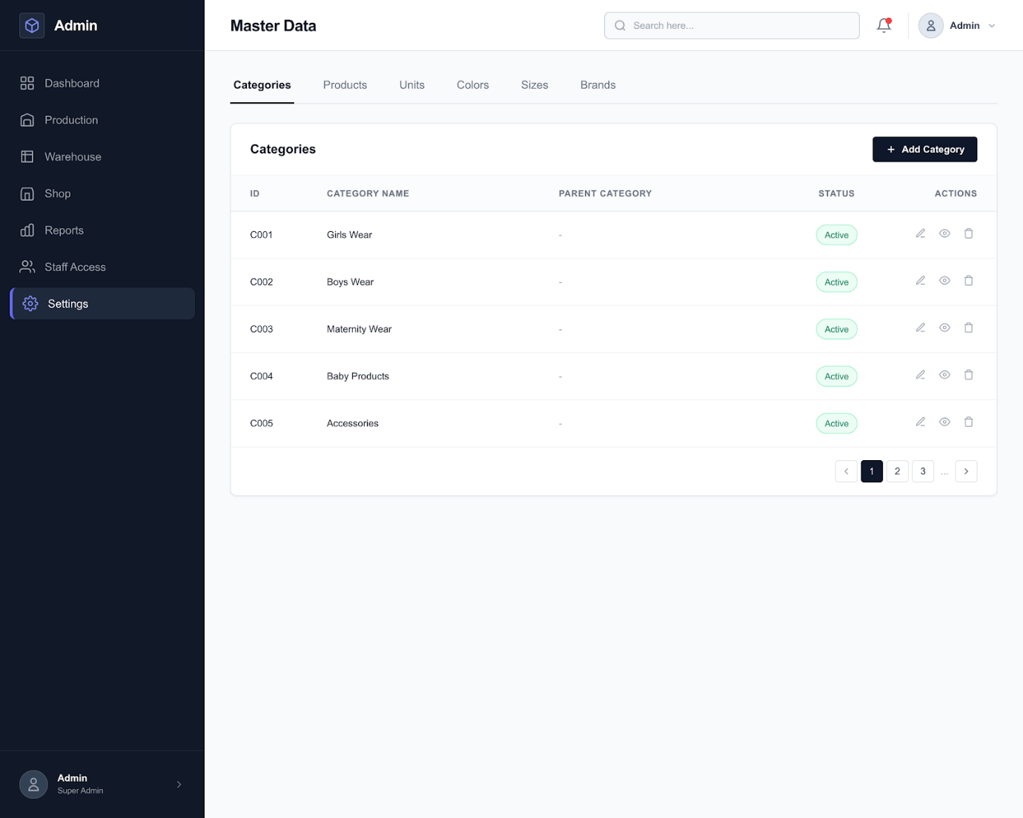

6.2 Source Type
Source | Meaning
OWN_PRODUCTION | Manufactured by the company's production units.
EXTERNAL_PURCHASE | Purchased from another seller/manufacturer for resale.

6.3 Locations
Locations should support production units, warehouses, shops, racks, shelves and bins so that inventory can be traced to its physical location.

7. Production Module
Production converts a planned quantity into finished, QC-approved inventory and records the operational history at each stage.
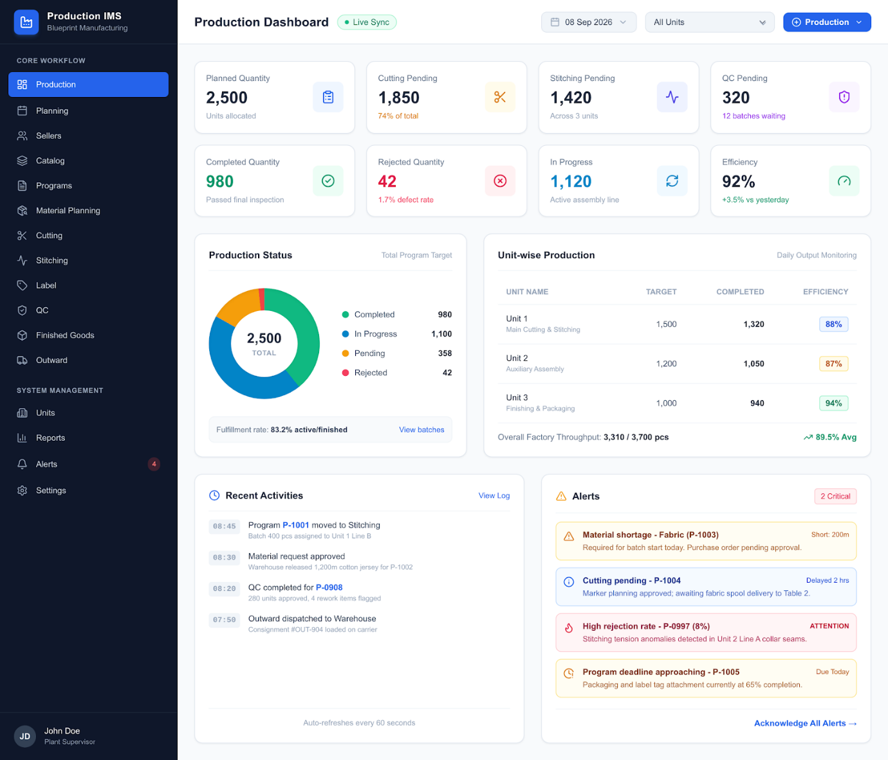

7.1 Seller
- Seller/vendor identity and contact information
- GST and address
- Payment terms
- Seller type and active status
Products/categories handled
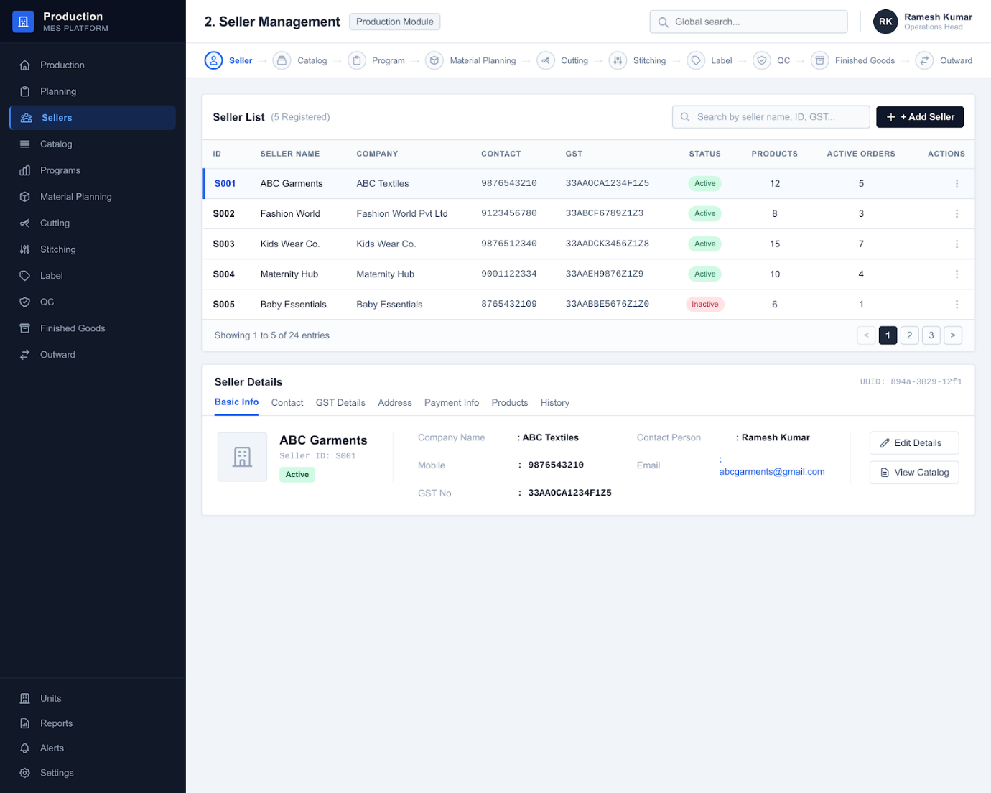

7.2 Catalog
Defines products and their sellable variants. Each variant should have a unique SKU/barcode and independent stock quantity.
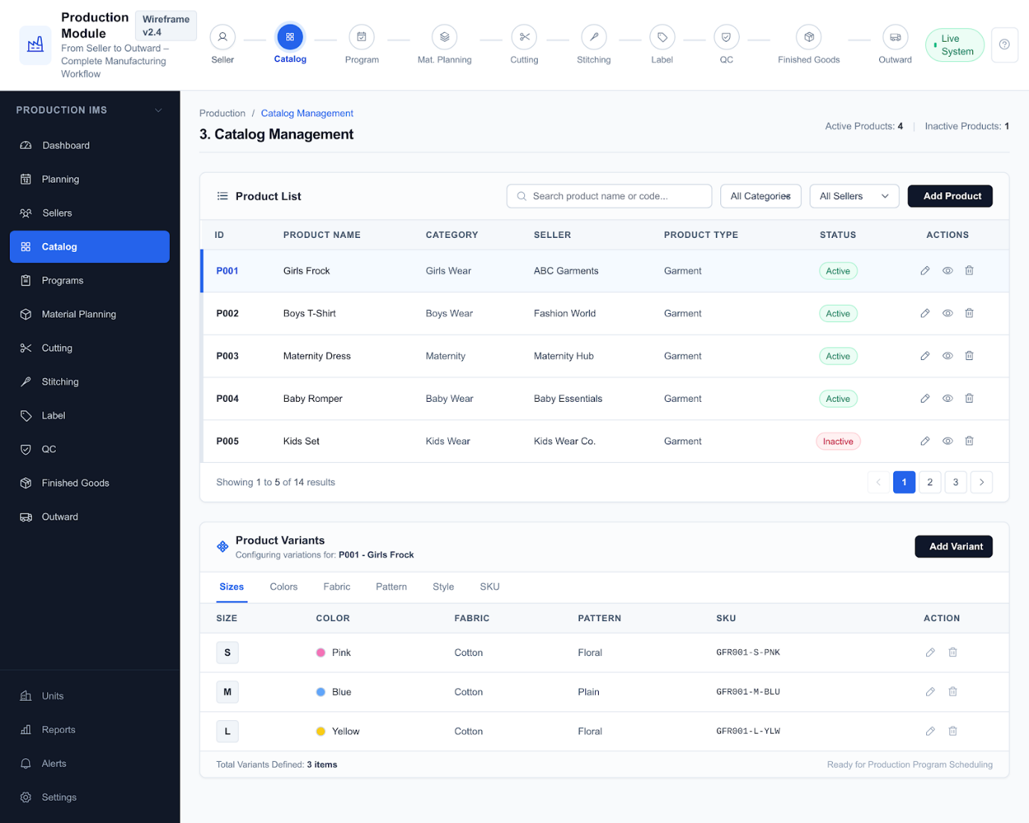

7.3 Program
- Create program number
- Select product/variants and planned quantity
- Select production unit
- Set target date and priority
- Assign staff
- Track program status
Flow: Draft → Approved → Scheduled → In Progress → Completed → Outward.
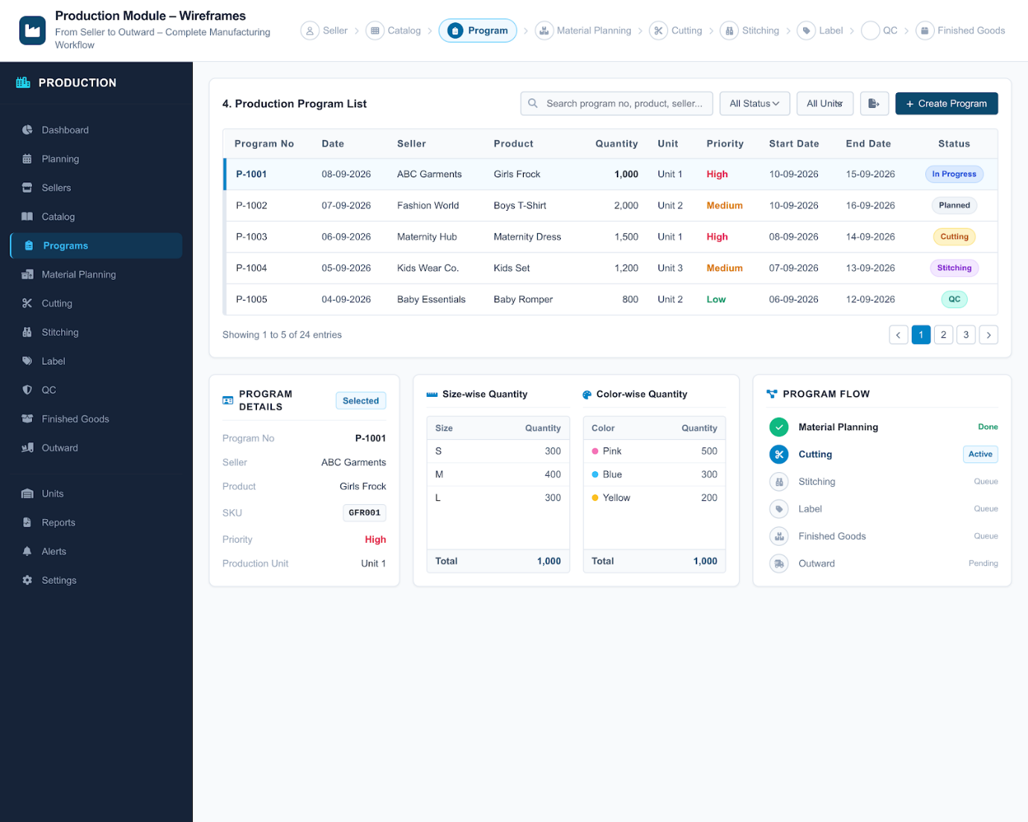

7.4 Cutting
- Issue material/fabric
- Record planned, cut, rejected and wastage quantities
- Assign operator and production unit
Track balance quantity and completion
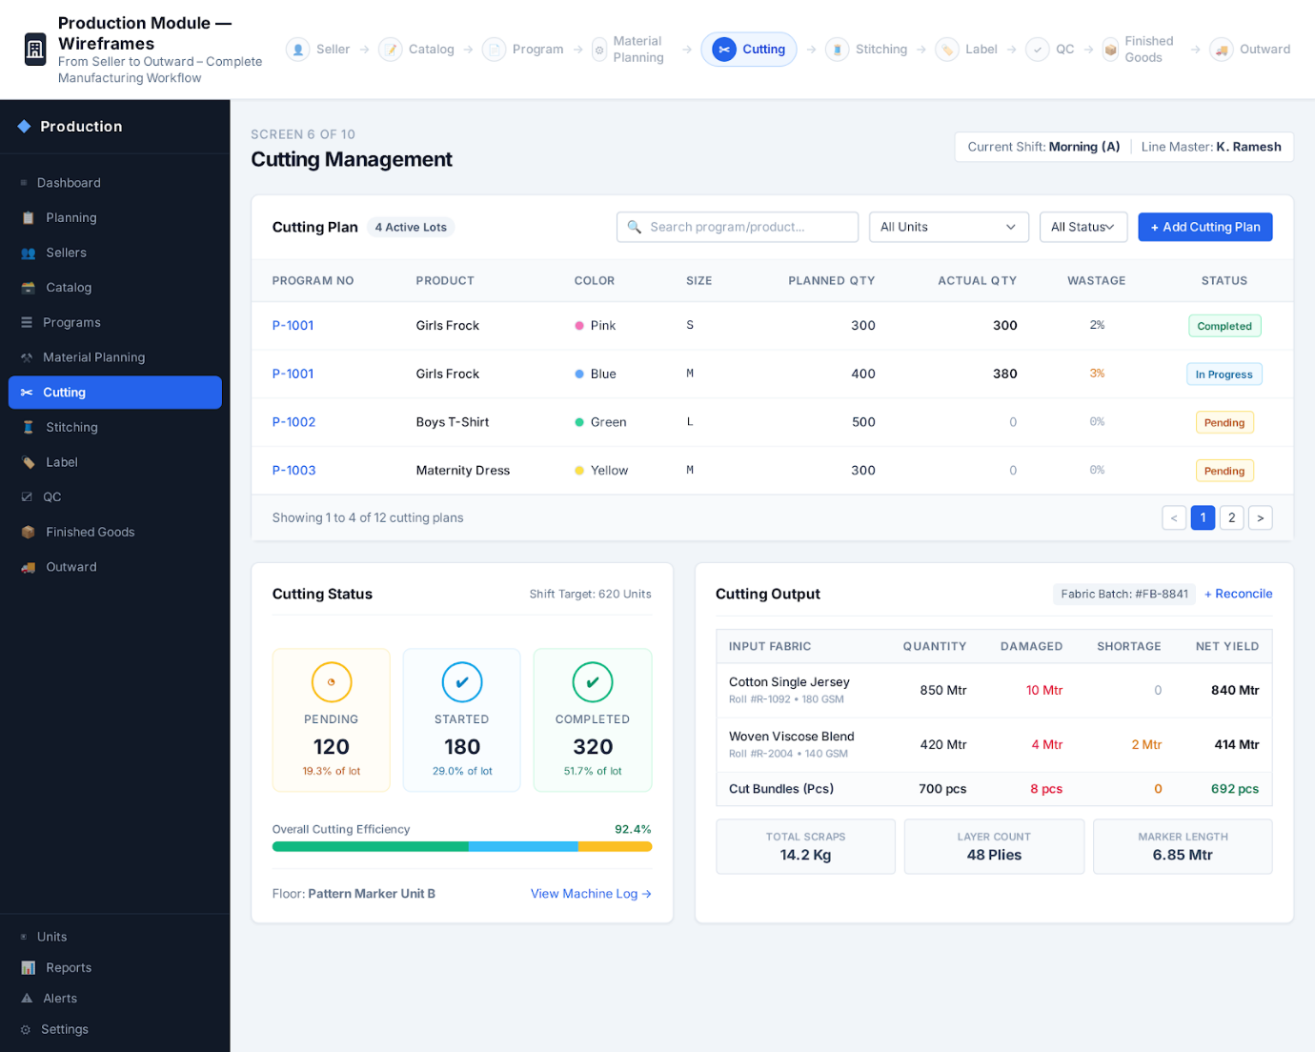

7.5 Stitching
- Receive cut quantity
- Record stitched quantity
- Record rejection and rework
- Assign worker
Track start/completion and balance(start date , end date)
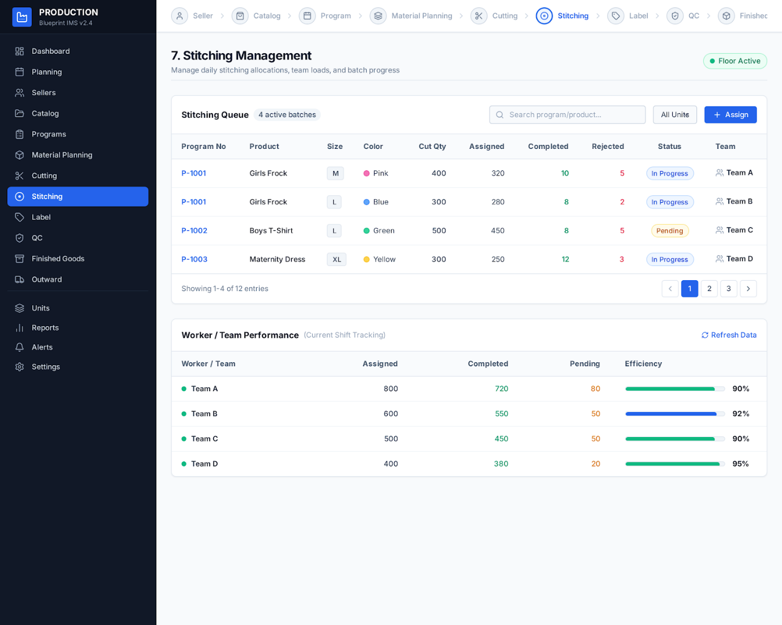

7.6 Label
- Prepare brand, size, price, QRcode and care labels
- Record required, printed, used and damaged quantities
Link labels to product/variant/batch
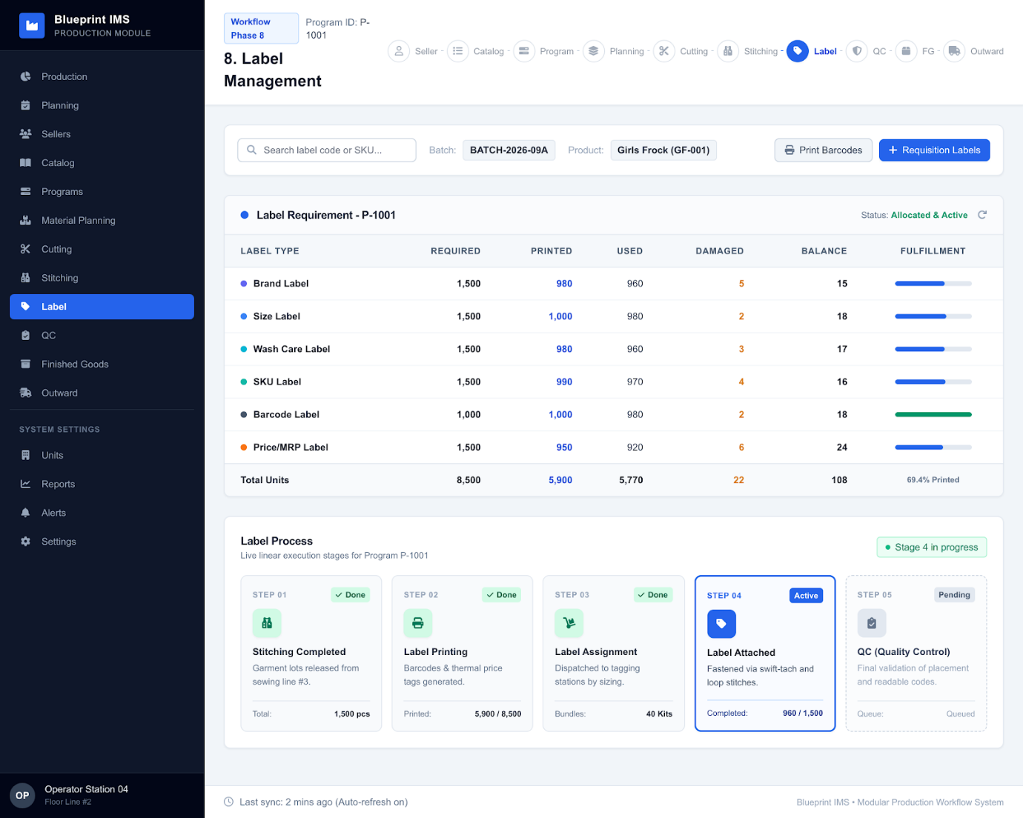

7.7 Quality Control
- Inspect stitching, fabric, color, size, label, barcode and finishing
- Record passed, rejected and rework quantities
Approve only acceptable finished quantity for stock
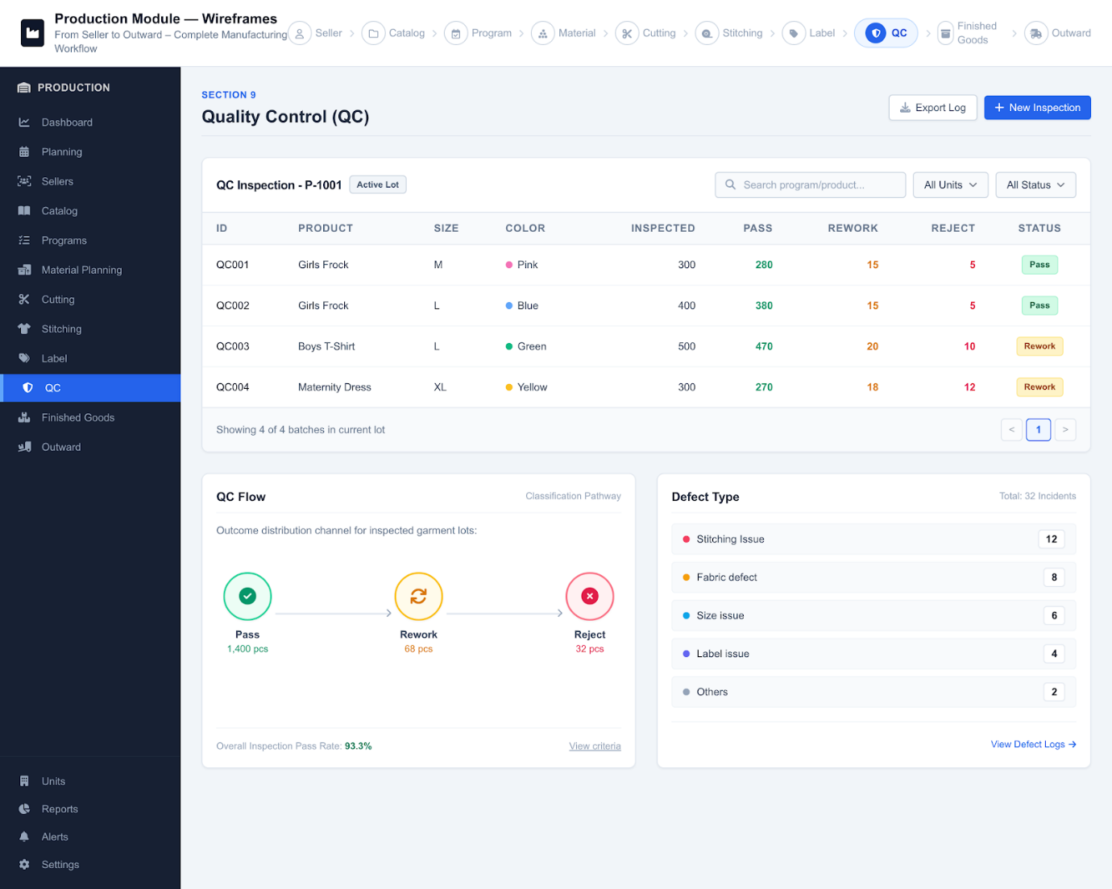

7.8 Outward / Batch
- Create batch number
- Link program and QC result
- Pack and record boxes/quantities
- Select destination warehouse
- Record preparation and approval
Production flow: Program → Cutting → Stitching → Label → QC → Batch → Production Outward → Warehouse Inward.
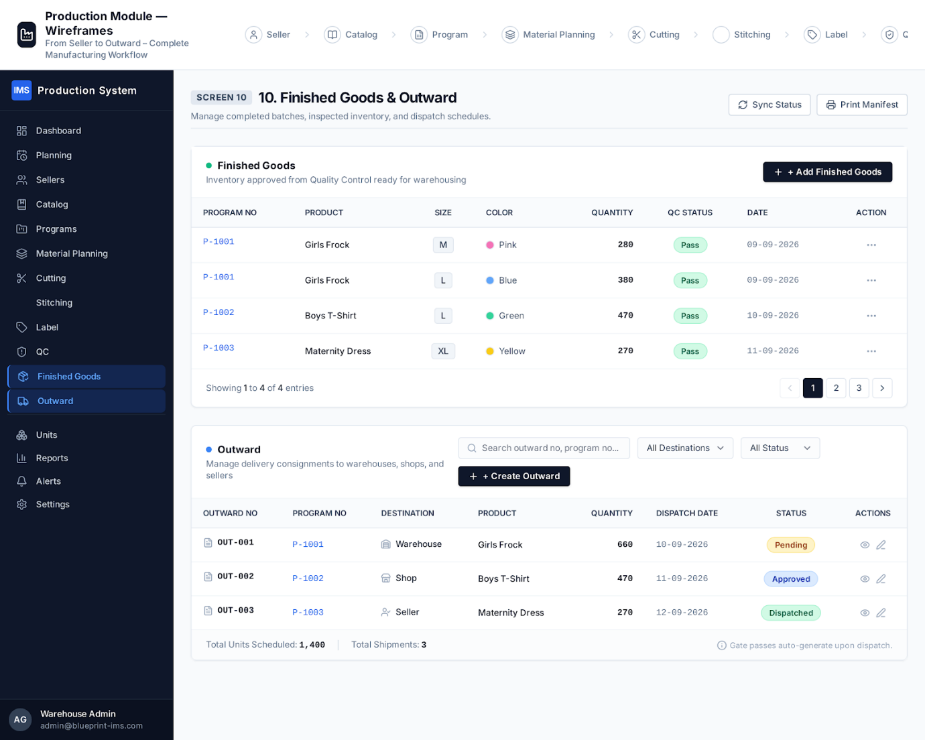

7.9 Production Reports
- Program status
- Unit-wise production
- Cutting and stitching output
- QC pass/rejection/rework
- Wastage
- Production cost
- Batch history
- Pending and delayed production

8. Warehouse Module

8.1 Dashboard
- Available, reserved and damaged stock
- Stock value
- Inward/outward
- Pending allocation
- Transfers
- Returns
- Low stock
- Delivery status

8.2 Inward
Warehouse inward accepts goods from own production, external purchases, warehouse transfers and approved returns.
- GRN(Goods Received Note)/inward number
- Source and reference document
- Product/SKU/variant
- Received, damaged and accepted quantities
- Warehouse and storage location
Verification staff and date
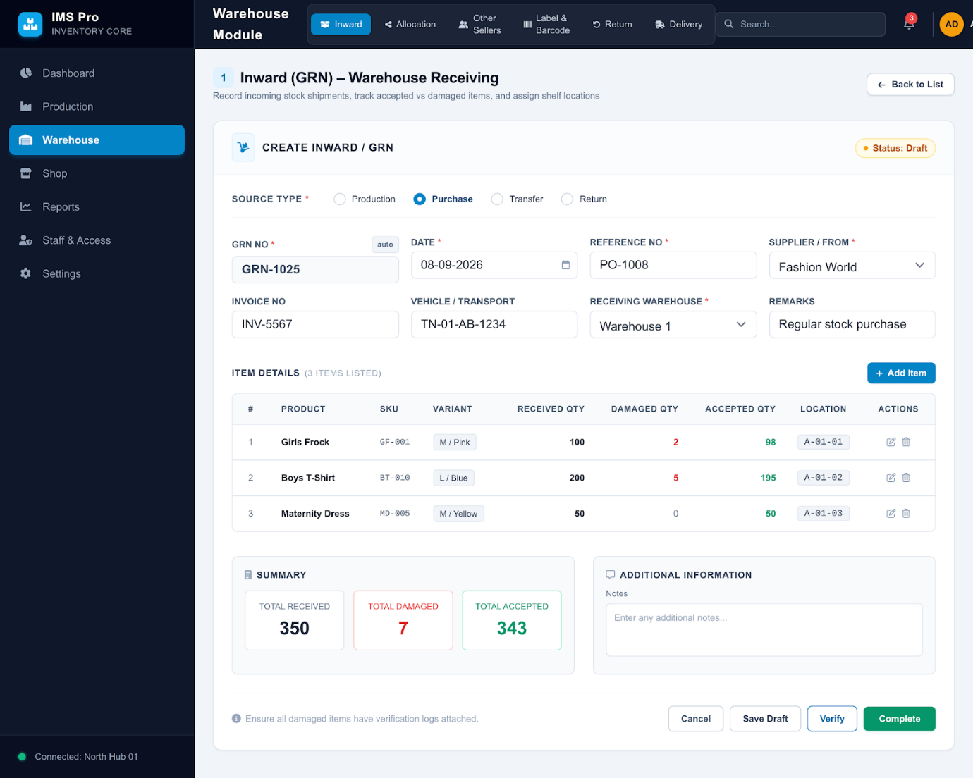

8.3 Allocation
Warehouse stock is allocated to website, WhatsApp, Shop 1, Shop 2 or other approved channels.
Flow: Allocation Request → Stock Check → Reservation → Approval → Picking → Packing → Dispatch → Destination Stock.
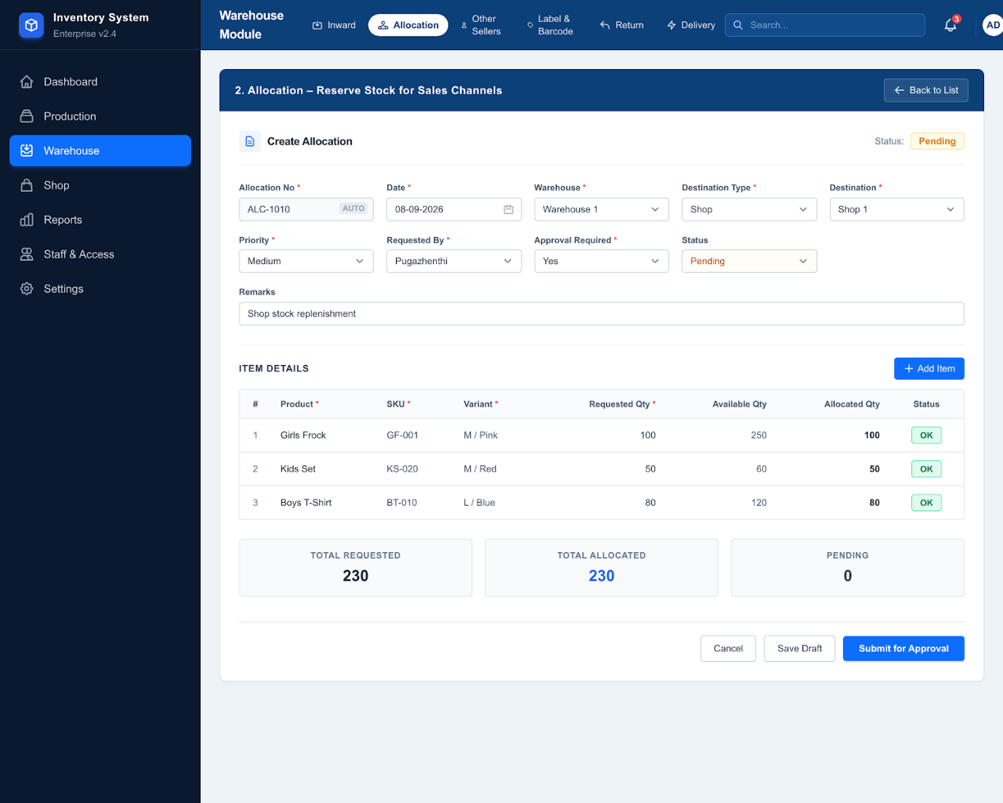

8.4 Other Sellers
Manages external purchases separately from own production, including seller, invoice, purchase price, quantity, GST, payment status and receiving warehouse.
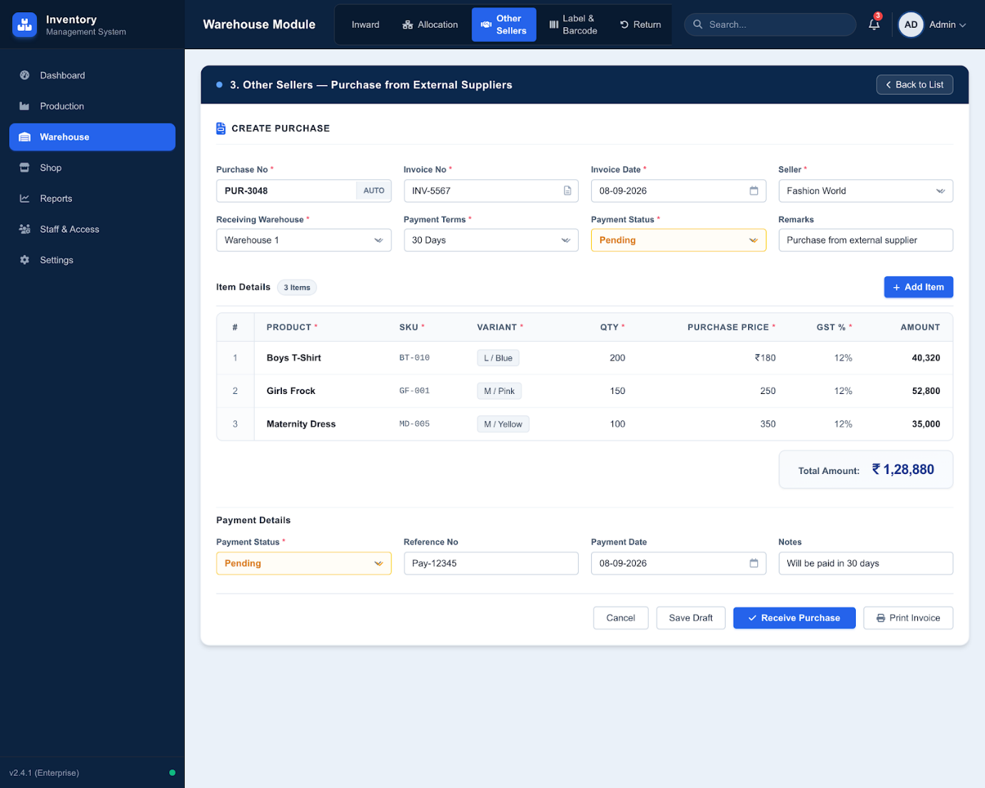

8.5 Returns
Receives returns from shops and digital orders. Returned goods are inspected and classified as good, damaged, defective, wrong product, wrong size or missing.
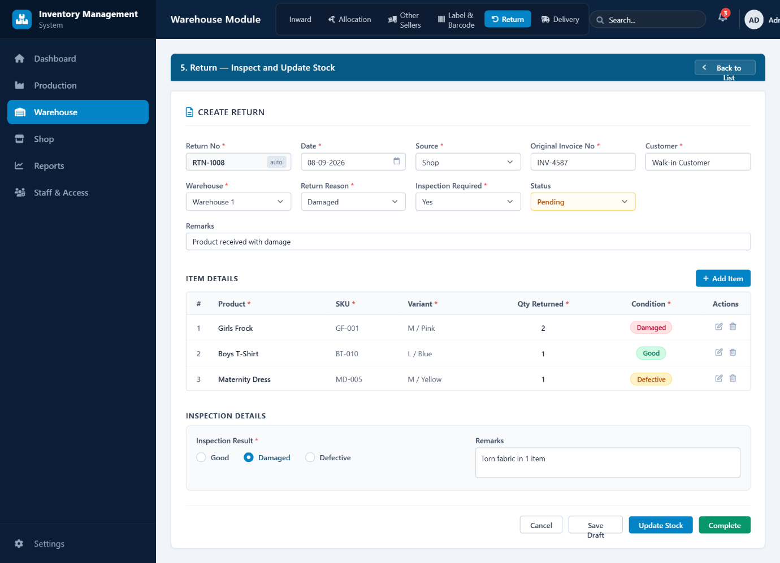

8.6 Label & Barcode
Generate product, SKU, price, box, batch and storage-location labels.
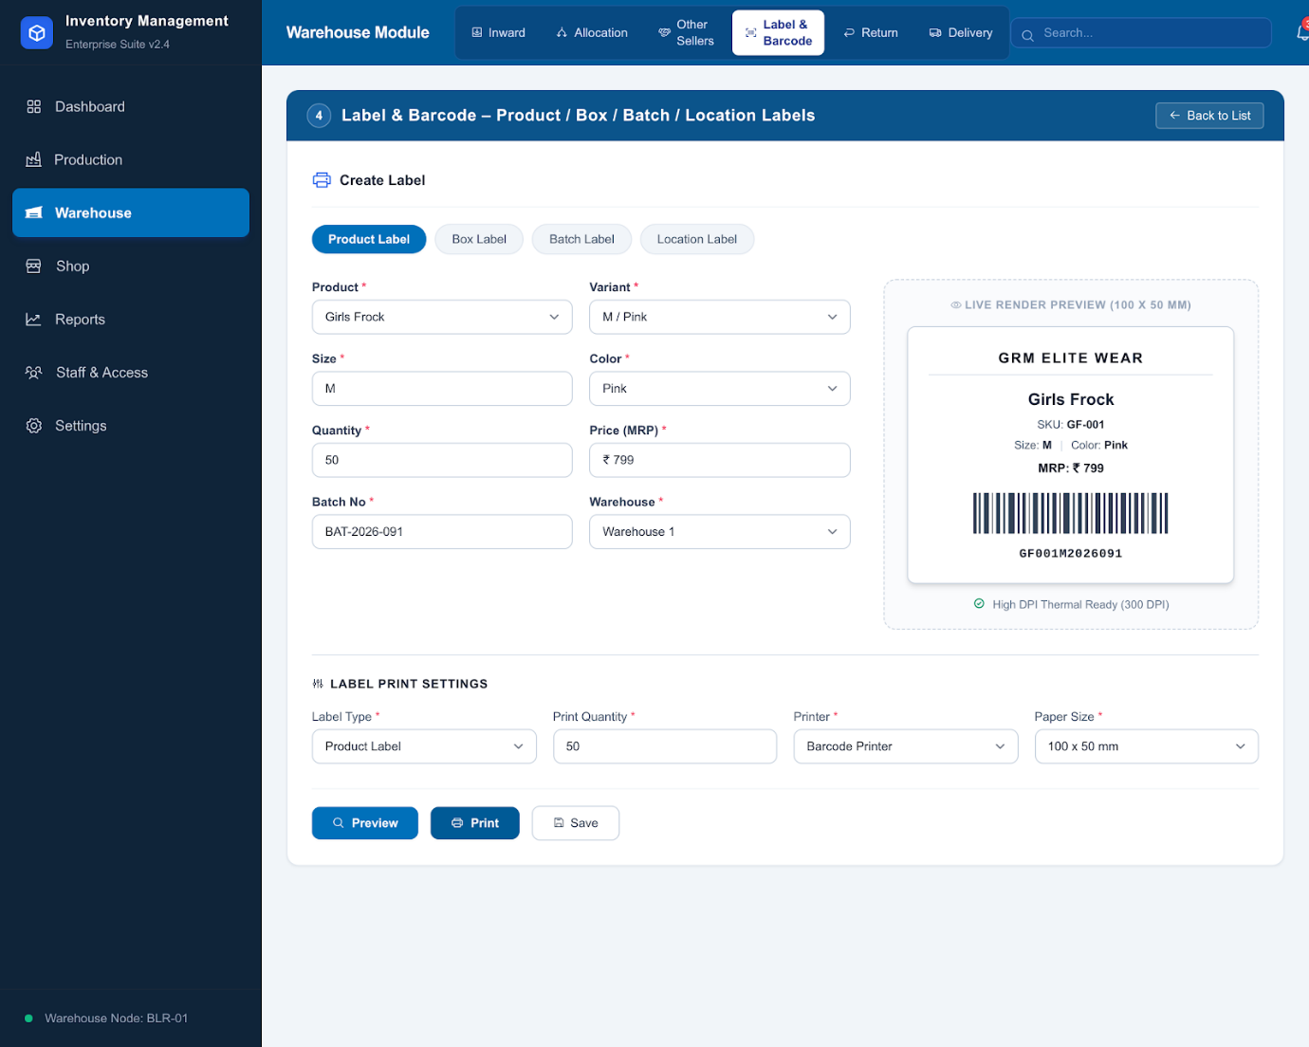

8.7 Delivery
Order(Request from shop) → approved → reservation → picking → packing → invoice → dispatch → transit → delivery or return.
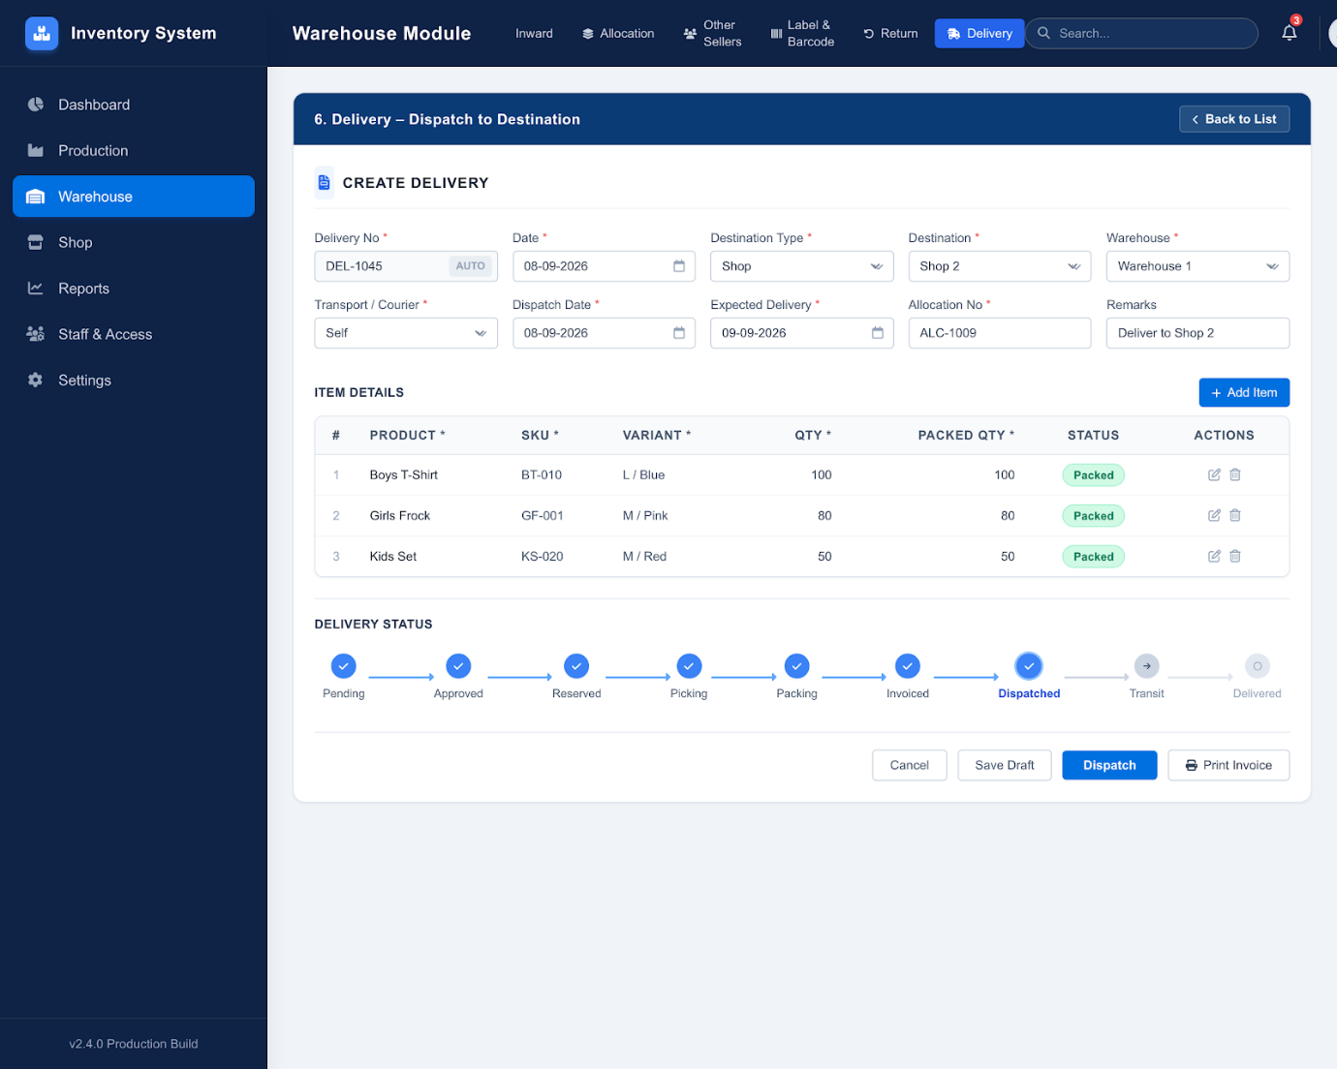

8.8 Transfers
Support warehouse-to-warehouse and warehouse-to-shop transfers with source, destination, SKU, quantity, approval and receiving confirmation.

8.9 Warehouse Reports
- Stock by location
- Inward/outward
- Allocation
- Transfers
- Returns
- Damaged stock
- Seller purchases
- Stock valuation
- Fast/slow moving items

9. Shop Module

9.1 Dashboard
- Daily/monthly sales
- Current stock
- Returns and exchanges
- Payment summary
- Low stock
- Top products
Staff performance
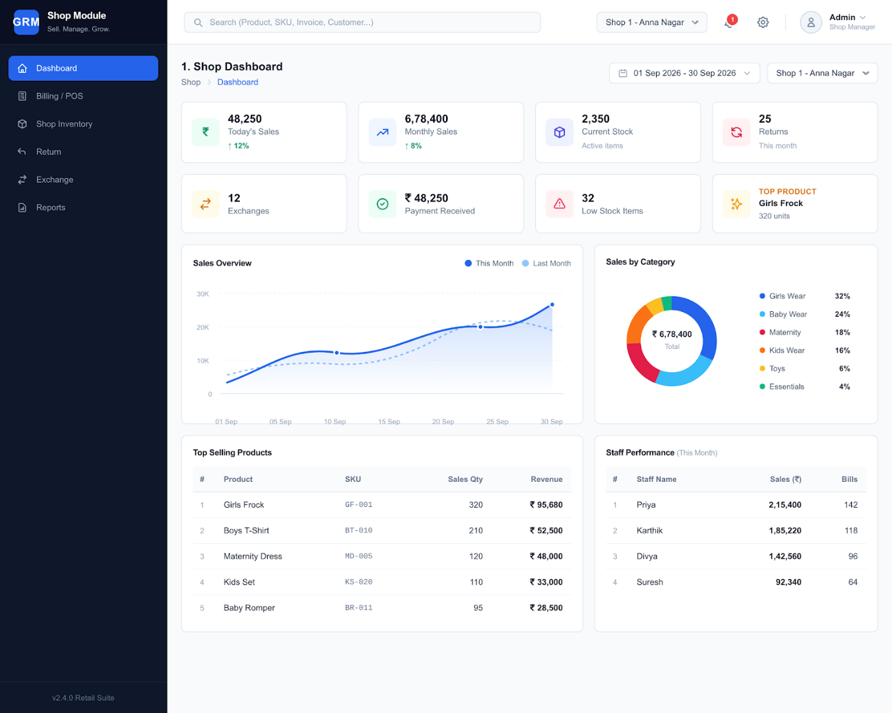

9.2 Billing / POS
Barcode Scan → Product/Variant → Quantity → Discount → Tax → Payment → Invoice → Stock Reduction.
- Cash, UPI, card and online payment modes
- Customer details when required
- Invoice numbering
- Discount and GST calculation
- QRcode scanning
Receipt/invoice printing
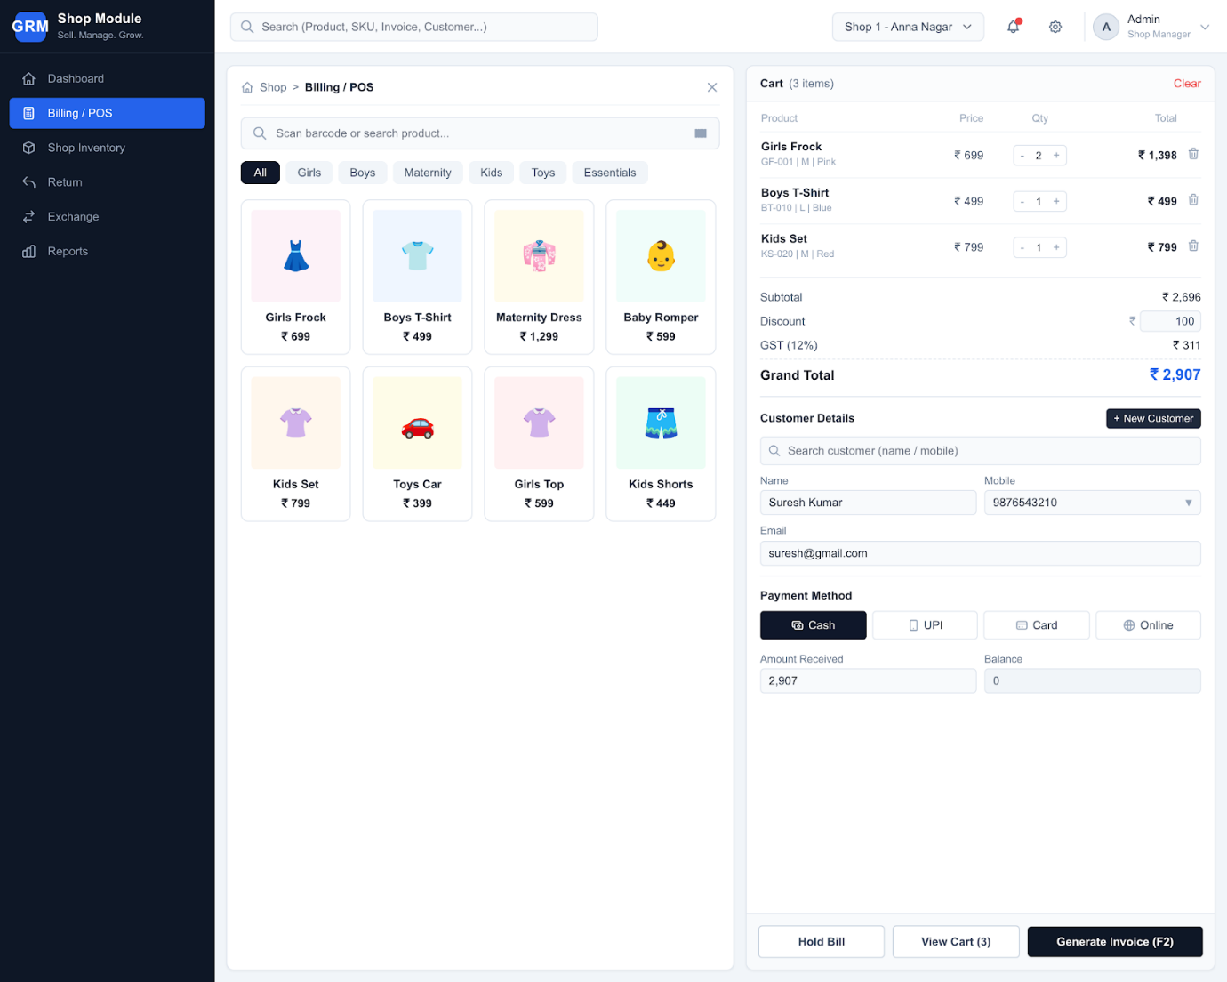

9.3 Shop Inventory
- Receive stock
- Transfer stock
- Physical stock adjustment
- Damaged/missing stock
- Low-stock monitoring
QR code-based stock checking
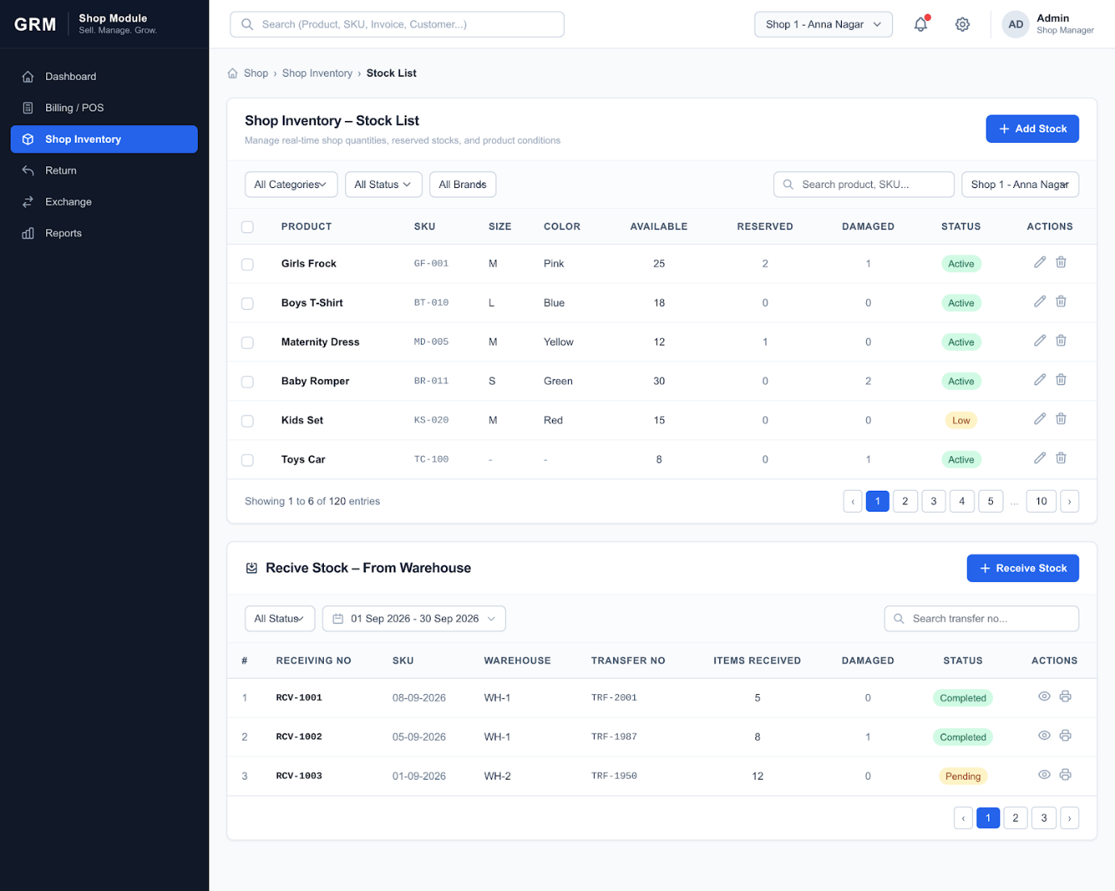

9.4 Return
Original Invoice → Select Item → Return Reason → Inspection → Accept/Reject → Refund or exchange → Inventory update.
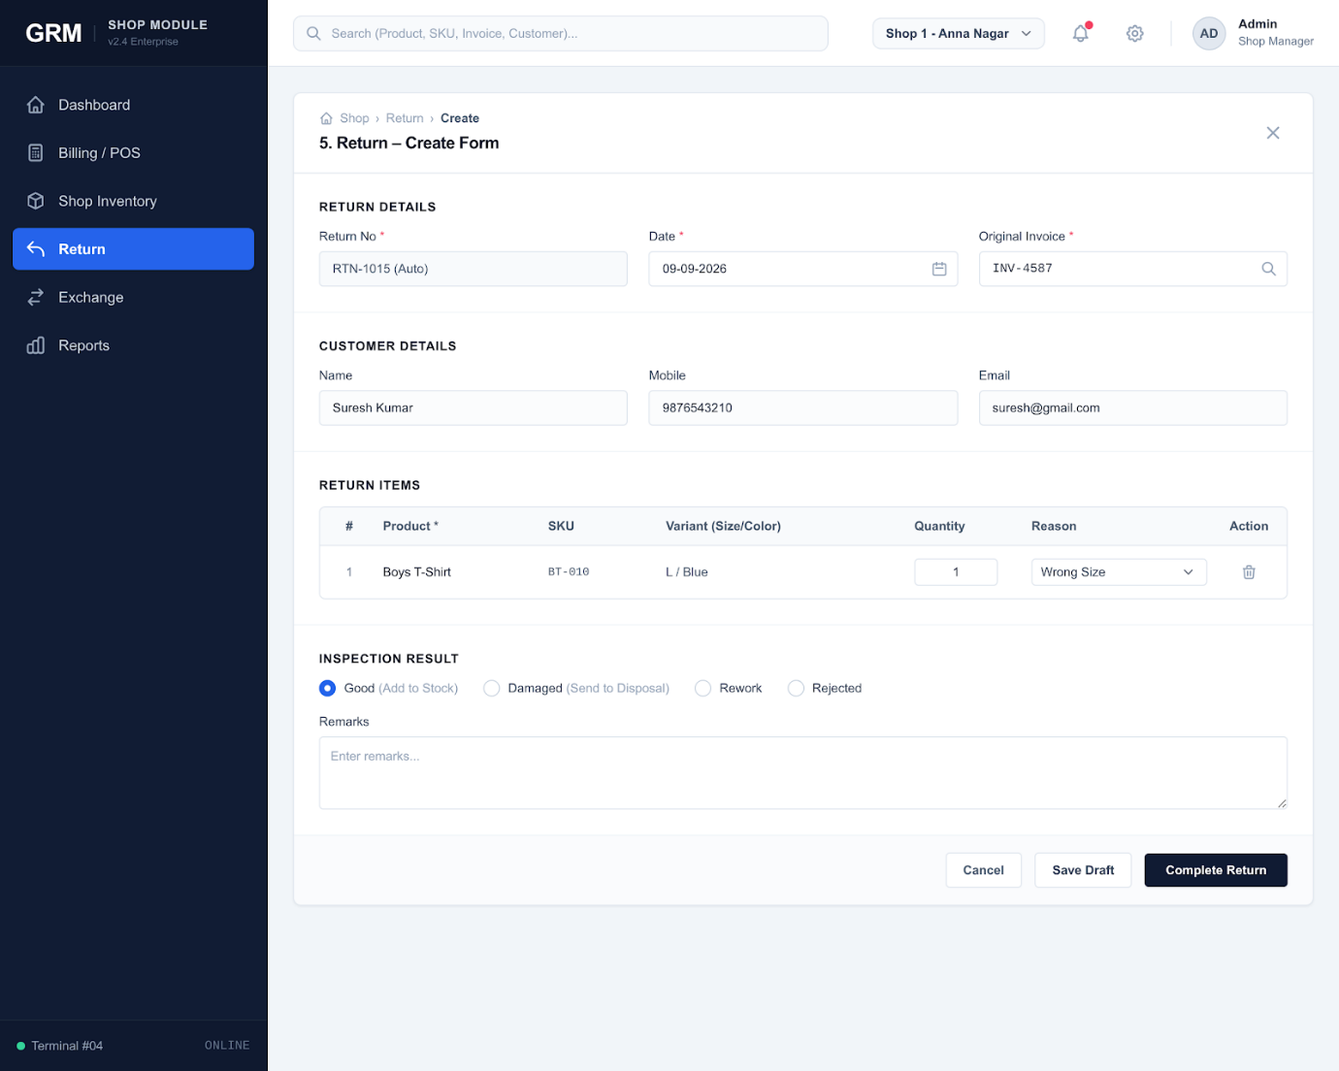

9.5 Exchange
Original Invoice → Receive old item → Select replacement → Calculate price difference → Collect/refund difference → Complete exchange.
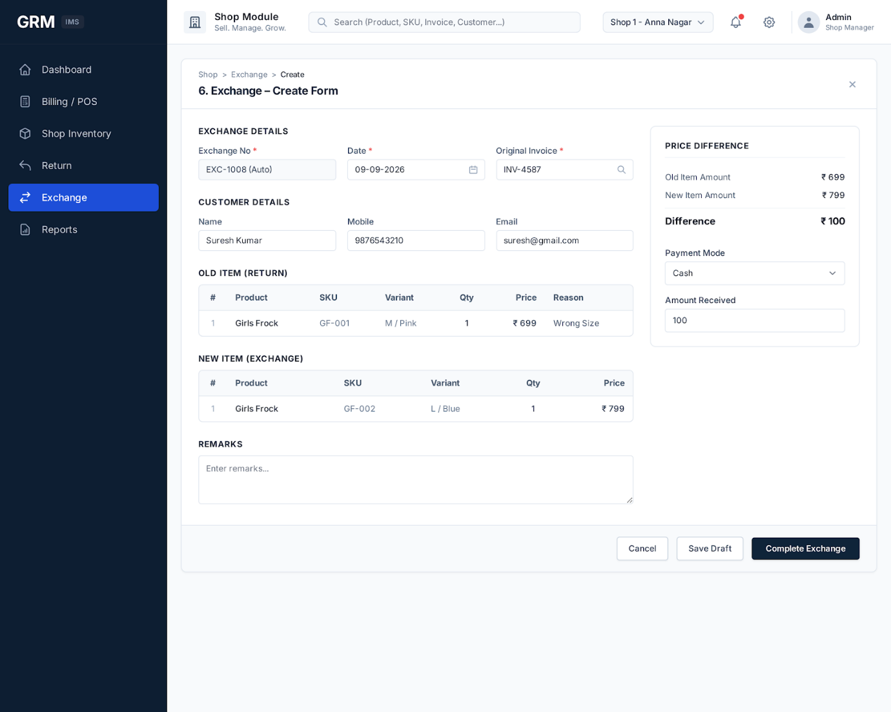

9.6 Shop Reports
- Daily/monthly sales
- Product/category sales
- Payment method
- Returns and exchanges
- Refunds
- Discounts
- GST
- Top/slow-moving products
- Shop comparison

10. Sales Channel Workflow

10.1 Shop
Customer → POS → Payment → Invoice → Shop Stock Reduction.

10.2 Website / WhatsApp
Order → Stock Availability → Reservation → Payment → Warehouse Picking → Packing → Invoice → Dispatch → Delivery → Return/Exchange if applicable.

10.3 Channel Allocation
Warehouse allocation should reserve stock before dispatch so that the same units cannot be sold through another channel.

11. Stock Management Rules
The system should maintain a central stock ledger. Stock should not be changed directly by ordinary users; it should change through approved transactions.
Transaction | Effect
Production Inward | + Stock at warehouse
External Purchase Inward | + Stock at warehouse
Warehouse Transfer In | +
Warehouse Transfer Out | -
Shop Transfer In | +
Shop Sale | -
Customer Return (approved good) | +
Damaged/Disposal | -
Stock Adjustment | +/- with reason and approval
Allocation | Moves quantity to reserved stock; final deduction occurs according to dispatch/business rule
Current Stock = Opening + Inward + Transfer In + Approved Returns − Sales − Transfer Out − Damage/Disposal ± Adjustments.

12. Return & Exchange Control
- Every return must reference the original invoice/order.
- Return reason is mandatory.
- Returned goods must be inspected before becoming sellable stock.
- Good stock returns to available inventory; damaged/defective items move to a controlled damage/rework/disposal state.
- Exchange must record both the original item and replacement item.
- Price difference must create a payment or refund transaction.
- Return/exchange actions must be included in sales and inventory reports.

13. Staff, Roles & Security
Role Example | Typical Access
Super Admin | All modules and configuration
Admin | Business administration and approvals
Production Manager | Programs, production stages, QC and production reports
Production Staff | Assigned production operations
Warehouse Manager | Warehouse transactions, allocation, transfers and approvals
Warehouse Staff | Receiving, picking, packing and dispatch
Shop Manager | Shop inventory, sales, returns and staff monitoring
Billing Staff | POS billing and permitted returns
Accountant | Payments, purchase/sales financial reports
Report Viewer | Read-only reports
Permission actions: View, Create, Edit, Delete, Approve, Print and Export.

14. Audit & Notification System

14.1 Audit Log
Record user, date/time, module, action, reference number, previous value, new value and relevant system metadata for sensitive operations.

14.2 Notifications
- Low/out-of-stock
- QC pending
- Production delayed
- Pending inward
- Pending allocation
- Pending delivery
- Return pending
- Stock mismatch
- Program deadline

15. Reporting Architecture
Report Group | Key Reports
Sales | Daily/monthly, shop-wise, channel-wise, product/category-wise, payment-wise
Production | Program, unit-wise output, cutting, stitching, QC, rejection, rework, wastage
Warehouse | Stock, inward, outward, allocation, transfer, returns, valuation
Purchase | Seller-wise purchases, quantities, values and payment status
Shop | Sales, returns, exchanges, discounts, staff performance
Inventory | Current, reserved, damaged, low-stock, fast/slow-moving, valuation
Profitability | Sales value, purchase value, production cost, discounts and return impact

16. Core Database Structure
Entity Group | Main Tables / Entities
Access | users, roles, permissions, role_permissions, audit_logs
Organization | production_units, warehouses, shops, settings
Master | categories, subcategories, brands, products, product_variants, sizes, colors, units, sellers, customers
Production | production_programs, production_program_items, cutting_batches, cutting_items, stitching_batches, stitching_items, label_batches, label_items, qc_batches, qc_items, production_batches, production_outwards
Purchase | purchase_orders, purchase_items, purchase_inwards, purchase_inward_items
Warehouse | warehouse_allocations, allocation_items, warehouse_transfers, transfer_items, warehouse_returns, return_items, stock_adjustments
Sales | sales, sale_items, payments, deliveries
Returns | returns, return_items, exchanges, exchange_items
Inventory | stock_transactions, stock_balances
System | notifications, backups, audit_logs

17. End-to-End Business Scenarios

Scenario A — Own Manufactured Product
- Create/maintain product and variant.
- Create production program for a production unit.
- Complete cutting and stitching.
- Print/apply labels.
- Perform QC and approve passed quantity.
- Create production batch and outward.
- Receive batch at warehouse.
- Update warehouse available stock.
- Allocate stock to website, WhatsApp or shops.
- Sell and record the transaction.
- Process return/exchange if required.
- Update stock and reports.

Scenario B — Externally Purchased Product
- Create/select external seller.
- Create purchase record.
- Receive goods at warehouse.
- Verify quantity and condition.
- Generate labels/barcodes.
- Add accepted quantity to warehouse stock.
- Allocate to sales channels.
- Sell through shop, website or WhatsApp.
- Process return/exchange under the same controlled return flow.

18. Recommended Status Model
Process | Statuses
Production Program | Draft, Approved, Scheduled, In Progress, Completed, Hold, Cancelled
QC | Pending, Passed, Partial, Rework, Rejected, Completed
Warehouse | Pending, Received, Verified, Allocated, Picked, Packed, Dispatched, Completed
Sales | Draft, Confirmed, Paid, Packed, Shipped, Delivered, Cancelled, Returned
Return | Requested, Received, Inspecting, Approved, Rejected, Refunded, Exchanged, Closed

19. Key Business Controls
- Use unique SKU and barcode for every sellable product variant.
- Maintain stock separately by location.
- Separate available, reserved, damaged and returned stock states.
- Do not allow sales beyond available stock unless an explicit backorder rule is implemented.
- Require approval for stock adjustments and sensitive transfers.
- Use original invoice/order references for returns and exchanges.
- Keep own-production and external-purchase source information.
- Maintain complete stock movement history.
- Use role-based access for every module.
- Keep audit records for create, edit, approval, cancellation and stock-impacting operations.

20. Final System Flow
ADMIN / MASTER DATA → OWN PRODUCTION OR EXTERNAL PURCHASE → WAREHOUSE RECEIPT → AVAILABLE / RESERVED STOCK → ALLOCATION → SHOP / WEBSITE / WHATSAPP → SALE → DELIVERY → RETURN / EXCHANGE → INSPECTION → STOCK RESTORATION OR DAMAGE → REPORTING

21. Implementation Priority
Phase | Scope
Phase 1 | Authentication, roles, master data, locations, products, SKU/barcode and stock foundation
Phase 2 | Production: program, cutting, stitching, label, QC and batch/outward
Phase 3 | Warehouse: inward, stock, allocation, transfers, external sellers and delivery
Phase 4 | Shop: POS, inventory, returns and exchanges
Phase 5 | Reports, analytics, notifications and audit logs
Phase 6 | Testing, data migration, deployment, backup and user training

22. Success Criteria
- Management can see stock by warehouse, shop, product and variant.
- Every finished product can be traced from production/purchase to sale.
- Warehouse allocation prevents untracked stock commitments.
- Shop billing automatically affects shop inventory.
- Returns and exchanges correctly affect stock and financial records.
- External seller products remain distinguishable from own production.
- Users only access authorized operations.
- Reports reconcile with the stock ledger and transaction history.

Complete Timeline Summary
# | Main Module | Days
1 | Project Foundation | 1/2
2 | Authentication | 1
3 | Admin Dashboard | 1
5 | Product Master | 1/2
6 | Seller Master(production) | 1/2
7 | Customer Master(shop) | 1/2
9 | Roles & Permissions(staff) | 1
10 | Stock Management | 2
11 | Production Dashboard | 1/2
12 | Production Seller | 1/2
13 | Production Catalog | 1/2
14 | Production Program | 1/2
15 | Material Planning | 1
16 | Cutting | 1/2
17 | Stitching | 1/2
18 | Labeling | 1
19 | QC | 1/2
20 | Production Batch | 1/2
21 | Production Outward | 1/2
22 | Warehouse Dashboard | 1/2
23 | Warehouse Inward / GRN | 1
24 | External Purchase | 1
25 | Warehouse Stock | 1/2
26 | Allocation | 1
27 | Transfers | 1/2
28 | Warehouse Returns | 1/2
29 | Delivery | 1/2
30 | Shop Dashboard | 1/2
31 | Shop Inventory | 1/2
32 | POS / Billing | 1
33 | Shop Return | 1/2
34 | Shop Exchange | 1/2
35 | Website / WhatsApp Orders | 1
36 | Sales Reports | 1/2
37 | Production Reports | 1/2
38 | Warehouse Reports | 1/2
39 | Purchase Reports | 1/2
40 | Shop Reports | 1/2
41 | Profitability Reports | 1/2
42 | Notifications | 1
43 | Audit Logs | 1
44 | Settings | 1
45 | Backup | 1
46 | Testing | 5
47 | Buffer time | 5
Total | Complete Project | 40 working days
25 working days Submission date 09.10.2026

End Documentation Thank you

